React Practice Task 1 – Job Oriented Courses UI

Question:
Create a React application that displays the “Job Oriented” courses section shown in the image. Use functional components and props to avoid repeating code for each course card.


Question:
Create a React application that displays the following scenario shown in the image. Use functional components and props drilling to pass the properties from Component to the CourseDetails Components.

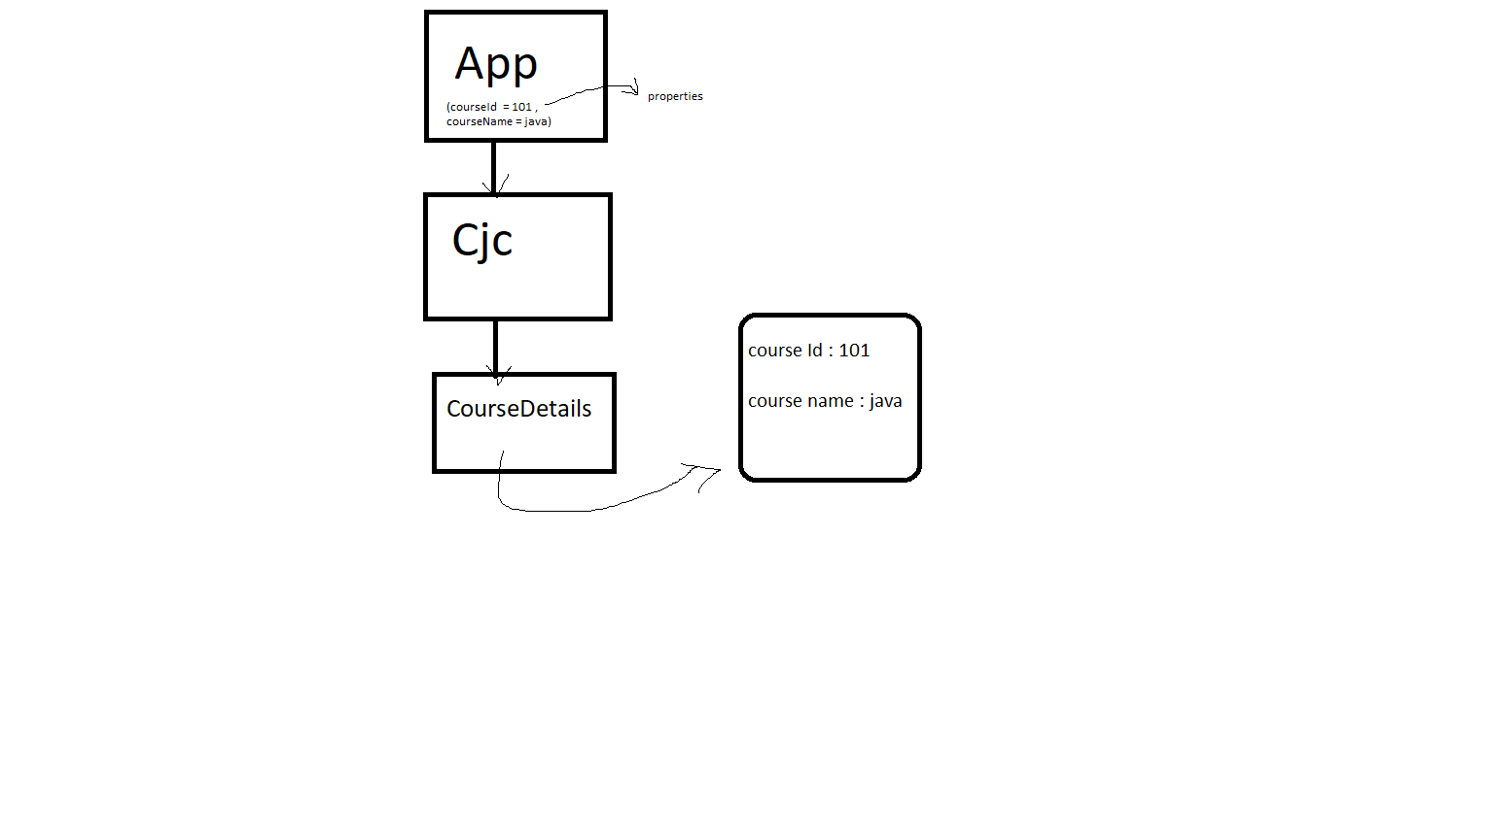

Task Description:
Create a Toggle Switch component using React Class Component that uses state to control whether the switch is ON or OFF.
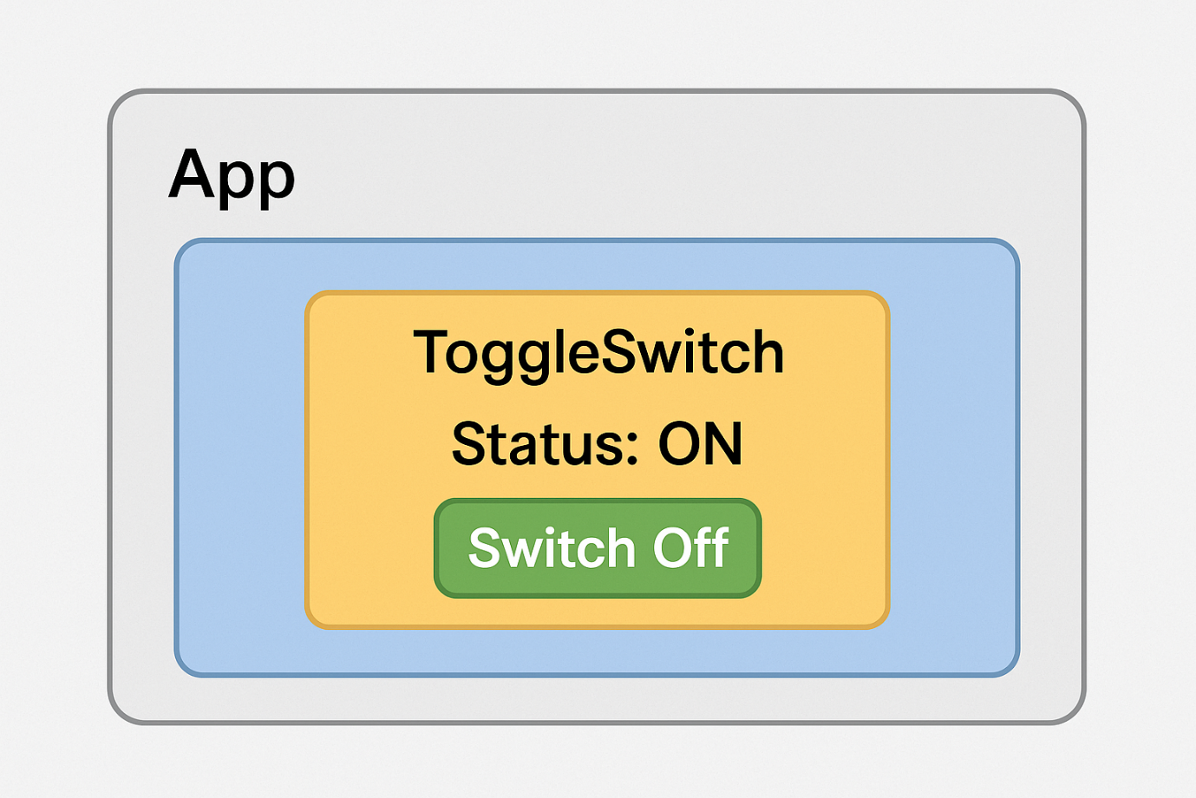

Question:
Create a React class component named LikeButton that:
- Maintains a piece of state called liked, which is initially false.
- Renders a button that displays the text:
  - "Like 🤍" when liked is false
  - "Liked ❤️" when liked is true
- When the button is clicked, it should toggle the liked state between true and false, updating the button text accordingly.


Dynamic Color Box

👉 Description:
Click a button to randomly change the background color of a box. Using state concepts in react.
Change Color

Question:
Create a React application that displays the following scenario shown in the image. When we click on Count++ count will increase by 1 and when click on Count – count will decrease by 1 this will be achieved By using class component as well as function component both with state managing.

Count --
Count ++
Count : 1

Counter
App

Question on props concepts :

Question 1:
Create a program to Send the "brand" property from the Garage component to the Car component:

Question 2:
Create a variable named carName and send it to the Car component:

Question 3 :
Create an object named carInfo and send it to the Car component:

Question 4 :

Which is a correct way of receiving, and using a prop named firstname , in a function class?

- function Person(props) {
return <h2>My name is { props.firstname }!</h2>;
}
- function Person(firstname) {
return <h2>My name is { firstname }!</h2>;
}
- Both Of the above is correct

Which one is a correct way of sending the value ‘Jonh’ via the ‘firstname’ property to the Person component?
r

- root.render(<Person firstname='John' />);

- root.render(<Person props(firstname='John') />);

- root.render(Person(firstname='John'));

correct

